1. list all the JavaScript data types

String  
 Number  
 Bigint  
 Boolean  
 Undefined  
 Null  
 Symbol

Object

2. how would you break the below javascript into to lines so world Appears on a second line

<html>

   <body>

      <script language = "javascript" type = "text/javascript">

         <!--

            document.write("Hello <br> World! </br>")

         //-->

      </script>

   </body>

</html>

3. What are undeclared and undefined variables?

Undefined are varables that have nothing attached to them thay are undefined

4. Which symbol is used for single line comments and which for multi-line comments in Javascript?

/*

*/

5. List 5 JavaScript *Keywords*

Break

If

This

Var

With

5.1. 3 *Future reserved words*

Var

Case

If

6. With the below fragment, what is the output?

**----INCREMENT OPERATOR EXAMPLE----**  
Value of x : 10  
Value of x : 10  
Value of x : 11  
  
**----DECREMENT OPERATOR EXAMPLE----**  
Value of y : 20  
Value of y : 20  
Value of y : 19

7. a. equalitly oprator

b. webpage tag

c. further options for a tag

d. file extention for java script tag

e. assignment operator

8. how to disable / enable JavaScript in edge and chrome

<https://youtu.be/12OnQu06rkA>

9.comments in JavaScript

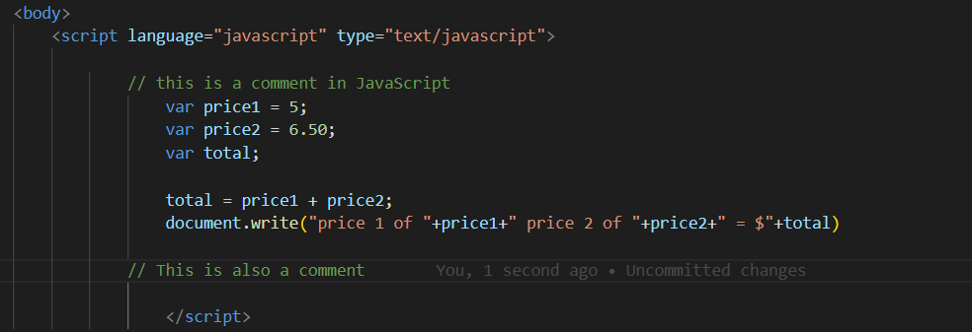

10.

Vscode (imo the best)

Sublimetext

atom